SIMATS ENGINEERING
ASSESSMENT TOOL 3

COURSE NAME: OBJECT ORIENTED ANALYSIS AND DESIGN COURSE CODE: CSA1110

COURSE OUTCOME COVERED
CO4:
implement object-oriented system layers using design principles and patterns, and integrate access and view layers with OODBMS (BL5)

Assessment Tool Weightage: 30%

QUESTIONS: 6 Total Marks:30
Annexure A

Reverse Engineering Task

Code of Conduct:
I LOSHINI.L 192571015 (Name / Reg No) certify that this submission is my original work and that I have adhered to the guidelines specified for this assessment.
I understand that any violation of academic integrity rules will result in disciplinary action.
Signature of the student:

LOSHINI.L
Annexure A
Reverse Engineering Task

Legacy E-Learning Management System

An existing E-Learning Management System has large modules responsible for student registration, course management, content delivery, assignment evaluation, and result generation. User interface code and business rules are tightly coupled, making modifications difficult.

Question:

Reverse engineer the existing system by identifying appropriate classes, responsibilities, attributes, methods, and relationships. Redesign the system using object-oriented principles and layered architecture, and explain how the redesigned structure improves cohesion, coupling, maintainability, and scalability.

Legacy Customer Support System

A customer support application uses multiple conditional statements to handle support requests through email, chatbot, telephone, and social media channels. Adding a new support channel requires changes to several existing modules.

Question:

Analyze the existing implementation and identify its object-oriented design limitations. Reverse engineer and refactor the system using suitable behavioral design patterns, and explain how the redesigned solution improves flexibility, extensibility, loose coupling, and maintainability.

Legacy Banking Transaction System

A banking application contains account management, transaction validation, fund transfer, loan processing, and transaction reporting within a few tightly coupled classes. Database operations are also embedded directly within business methods.

Question:

Reverse engineer the system by identifying appropriate domain classes, service classes, and data access components. Redesign the application using suitable layers and design patterns, and explain how the redesigned architecture improves separation of concerns, testability, and system maintainability.

Legacy Hotel Reservation System

A hotel reservation application directly performs OODBMS operations from reservation screens. The same database queries for rooms, guests, bookings, and payments are repeated across multiple modules.

Question:

Analyze the existing architecture and identify problems related to coupling, duplication, and persistence management. Reverse engineer the system by introducing suitable DAO, Repository, or Data Access patterns, and explain how the redesigned solution improves modularity, reusability, and OODBMS integration.

Legacy Transportation Management System

A transportation application contains separate modules for buses, trains, taxis, and rental vehicles. Object creation logic for each transportation type is duplicated across several parts of the application, making it difficult to introduce new transportation services.

Question:

Reverse engineer the system by identifying common abstractions, classes, and object relationships. Apply suitable creational design patterns, such as Factory Method or Abstract Factory, to redesign object creation and explain how the new design improves extensibility, scalability, and code reuse.

Legacy Healthcare Monitoring System

A healthcare monitoring application collects patient information, processes sensor readings, generates alerts, stores medical records, and produces reports. Several classes perform multiple unrelated tasks and directly depend on concrete implementations of monitoring devices and storage components.

Question:

Reverse engineer the application by identifying violations of SOLID principles, particularly SRP, OCP, and DIP. Redesign the classes using suitable abstractions, interfaces, and design patterns, and explain how the redesigned system improves cohesion, loose coupling, flexibility, testability, and maintainability.

RUBRICS FOR CALCULATION

Reverse Engineering Task

Criteria | Weightage | Exemplary (4) | Proficient (3) | Developing (2) | Beginning (1)
Understanding of System | 20% | Demonstrates clear and in-depth understanding of the system/product and its  functionality | Shows good understanding with minor gaps | Partial understanding; misses key aspects | Lacks understanding of the system/product
Decomposition | 25% | Effectively breaks down the system into components with detailed  analysis | Decomposes system with minor gaps in analysis | Limited or incomplete decomposition | Unable to analyze or break down system
Identification of Components | 20% | Accurately identifies all components and explains their  functions clearly | Identifies most components with minor errors | Identifies few components; explanations are weak | Unable to identify components or functions
Reconstruction | 20% | Successfully reconstructs or models the system with accuracy and  logic | Reconstruction is mostly correct with minor issues | Partial reconstruction; lacks clarity | Unable to reconstruct or model system
Documentation | 15% | Well-organized, clear documentation with diagrams and structured  explanation | Documentation is adequate with minor issues | Poorly organized or incomplete documentation | No proper documentation or presentation

Q1. Legacy E-Learning Management System

5 Marks
Scenario: The existing E-Learning Management System has large modules for student registration, course management, content delivery, assignment evaluation, and result generation. UI code and business rules are tightly coupled, making modifications difficult.

Understanding of the System
The legacy system is a monolithic application in which each 'module' (registration, course management, content delivery, evaluation, result generation) is implemented as one large class that mixes user-interface logic, validation rules, business computations, and direct data access. Because UI and business rules live in the same class, any change to a screen risks breaking business logic, and any change to a business rule requires touching UI-facing code
— a classic symptom of low cohesion and high coupling.

Decomposition of the System
The system can be decomposed along two axes: (a) functional decomposition into domain concepts — Student, Course, Enrollment, Content, Assignment, Evaluation, and Result — and (b) architectural decomposition into horizontal layers — Presentation, Application, Business Logic, and Data Access — so that each domain concept is manipulated only through its own well-defined class, and each layer has exactly one kind of responsibility.

Identification of Components

Class | Key Attributes | Key Methods | Responsibility
Student | studentId, name, email | register(), viewCourses(), viewResult() | Represents a learner and their profile/enrollment actions.
Course | courseId, title, syllabus | addContent(), listAssignments() | Represents a course and its content/assignment collection.
Enrollment | enrollmentId, studentId, courseId, status | enrollStudent(), dropCourse() | Associates a Student with a Course.
Assignment | assignmentId, courseId, dueDate | submit(), evaluate() | Represents a gradable task within a course.
Evaluation | evaluationId, assignmentId, score | calculateScore(), publishFeedback() | Encapsulates assignment-evaluation rules.
Result | resultId, studentId, courseId, grade | generateResult(), publish() | Aggregates evaluations into a final course result.
Relationships: Student 1..* — 1..* Course via Enrollment (many-to-many association); Course 1 — * Assignment (composition, assignments cannot exist without a course); Assignment 1 — 1 Evaluation; Student 1 — * Result.

Reconstruction: Redesigned Layered Architecture

The redesign separates the monolithic modules into a four-layer architecture following the Model-View-Controller idea within the Presentation Layer, and the DAO pattern within the Data Access Layer:
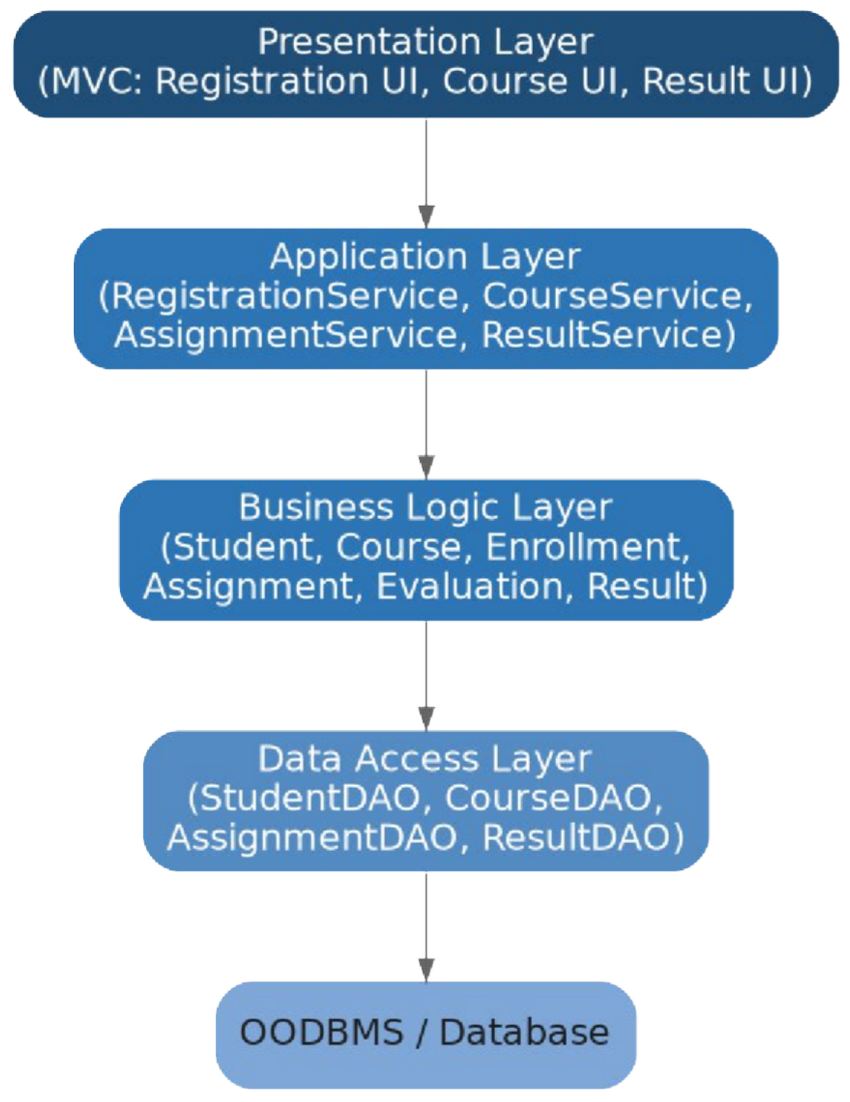
Figure 1: Redesigned layered architecture for the E-Learning Management System

  - Presentation Layer — RegistrationView, CourseView, ResultView: display data and capture input only; no business rules.
  - Application Layer — RegistrationService, CourseService, AssignmentService, ResultService: orchestrate use cases (e.g., enroll a student, submit an assignment).

  - Business Logic Layer — Student, Course, Enrollment, Assignment, Evaluation, Result: hold domain rules (e.g., eligibility to enroll, grade computation).
  - Data Access Layer — StudentDAO, CourseDAO, AssignmentDAO, ResultDAO: isolate all persistence/OODBMS operations behind interfaces.

Documentation: Improvement in Cohesion, Coupling, Maintainability, and Scalability
Cohesion: Each class now has a single, well-defined purpose (e.g., Result only aggregates grades), so every method inside a class is closely related to that one purpose — a direct improvement over the legacy 'god classes' that mixed unrelated responsibilities.
Coupling: Layers interact only through interfaces (Service and DAO interfaces), so the Presentation Layer no longer touches the database directly, and the Business Layer is unaware of UI details, dramatically reducing inter-module dependency.
Maintainability: Because UI, business rules, and persistence are separated, a change to the result-computation formula only touches the Result class in the Business Layer, and a redesign of the course page only touches CourseView — changes no longer ripple across unrelated modules.
Scalability: The layered structure allows the Application and Business layers to be scaled or deployed independently (e.g., as separate services) as the number of students grows, and new features (e.g., a new assignment type) can be added by extending existing classes rather than modifying large monolithic modules.

Q2. Legacy Customer Support System

5 Marks
Scenario: A customer support application uses multiple conditional statements to handle support requests through email, chatbot, telephone, and social media channels. Adding a new support channel requires changes to several existing modules.

Understanding of the System
The legacy system routes every incoming support request through a large conditional block (if/else or switch) that checks the channel type and executes channel-specific handling code inline. All channel-handling logic is centralized in one method, so the class knows the internal details of every channel it supports.

Object-Oriented Design Limitations
  - Violation of the Open/Closed Principle — adding a new channel (e.g., WhatsApp) requires modifying the existing conditional block rather than extending the system.
  - Low cohesion — a single class/method is responsible for the unrelated handling logic of four different channels.
  - Tight coupling — the request-handling class is directly coupled to the implementation details of every channel.
  - Poor testability — testing the email-handling logic in isolation is difficult because it is embedded inside a large conditional method along with the other channels.

Identification of Components for Refactoring

Component | Type | Responsibility
SupportContext | Context class | Holds a reference to the active ChannelStrategy and delegates request handling to it.
ChannelStrategy | Interface | Declares handle(request) — the common contract for all channel handlers.
EmailChannelStrategy | Concrete Strategy | Implements email-specific request handling.

Component | Type | Responsibility
ChatbotChannelStrategy | Concrete Strategy | Implements chatbot-specific request handling.
PhoneChannelStrategy | Concrete Strategy | Implements telephone-specific request handling.
SocialMediaChannelStrategy | Concrete Strategy | Implements social-media-specific request handling.

Reconstruction: Refactoring with the Strategy Pattern
The Strategy behavioral pattern is applied to eliminate the conditional block: each channel becomes an independent class implementing a common ChannelStrategy interface, and the SupportContext simply delegates to whichever strategy is configured, without knowing the channel-specific logic.
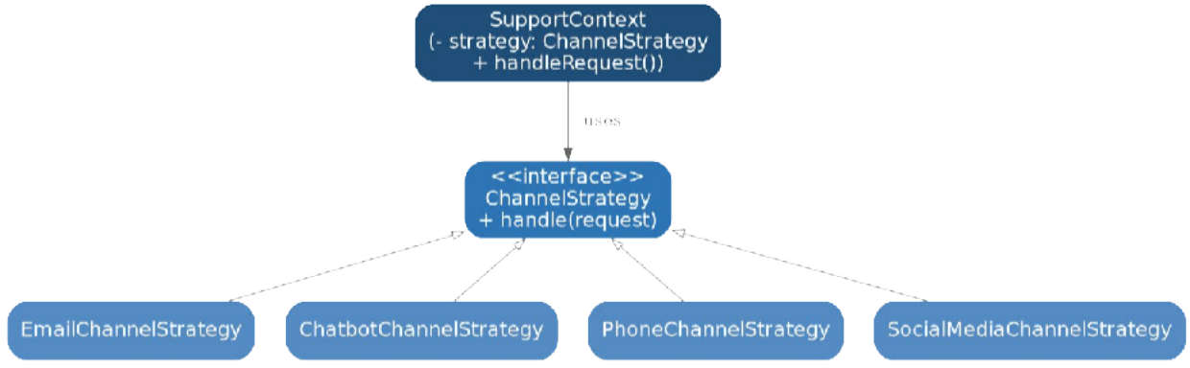
Figure 2: Strategy pattern applied to the customer-support channel handling

A complementary pattern can also be introduced: the Chain of Responsibility pattern to escalate unresolved tickets through support tiers (Level 1 → Level 2 → Supervisor) without hard-coding the escalation path inside a single class.

Documentation: Improvement in Flexibility, Extensibility, Loose Coupling, and Maintainability
Flexibility: The channel used to handle a request can be selected or changed at runtime simply by assigning a different ChannelStrategy object to the SupportContext.
Extensibility: A new support channel (e.g., WhatsApp) is added by creating one new class that implements ChannelStrategy — no existing class is modified, satisfying the Open/Closed Principle.
Loose Coupling: SupportContext depends only on the ChannelStrategy interface, not on any concrete channel implementation, so channel classes can evolve independently.
Maintainability: Each channel's logic is isolated in its own class, so a bug in chatbot handling can be fixed and unit-tested without risk of affecting email, phone, or social-media handling.

Q3. Legacy Banking Transaction System

5 Marks
Scenario: A banking application contains account management, transaction validation, fund transfer, loan processing, and transaction reporting within a few tightly coupled classes. Database operations are also embedded directly within business methods.

Understanding of the System
The legacy system concentrates account management, validation, fund transfer, loan processing, and reporting inside a small number of large classes, and these classes execute SQL/database calls directly inside their business methods. This means the business rules and the persistence mechanism are inseparable in the code.

Decomposition of the System
The system is decomposed into three categories of components: Domain classes (representing core banking concepts and their invariants), Service classes (orchestrating banking use cases), and Data Access components (isolating all database interaction).

Identification of Components

Category | Component | Responsibility
Domain Class | Account | Holds balance, account number, and enforces invariants (e.g., balance cannot go negative).
Domain Class | Transaction | Represents a single debit/credit event with amount, date, and type.
Domain Class | Loan | Represents a loan with principal, interest rate, and repayment schedule.
Service Class | AccountService | Coordinates account creation, balance inquiry, and status updates.
Service Class | FundTransferService | Orchestrates validated transfer between two accounts (debit + credit as one unit of work).
Service Class | LoanService | Handles loan application, approval, and interest computation logic.
Service Class | ReportService | Generates transaction and account statements.
Data Access | AccountDAO / TransactionDAO / LoanDAO | Encapsulate all SQL/OODBMS operations for their respective domain class.

Reconstruction: Redesigned Layered Architecture with Patterns
Database calls are extracted out of the business methods and placed behind dedicated DAO classes (DAO Pattern). A Facade (BankingFacade) is introduced to provide a single simplified entry point for a fund transfer that internally coordinates account validation, debit, credit, and logging as one operation. A Strategy pattern is used for interchangeable interest-calculation policies across loan types.

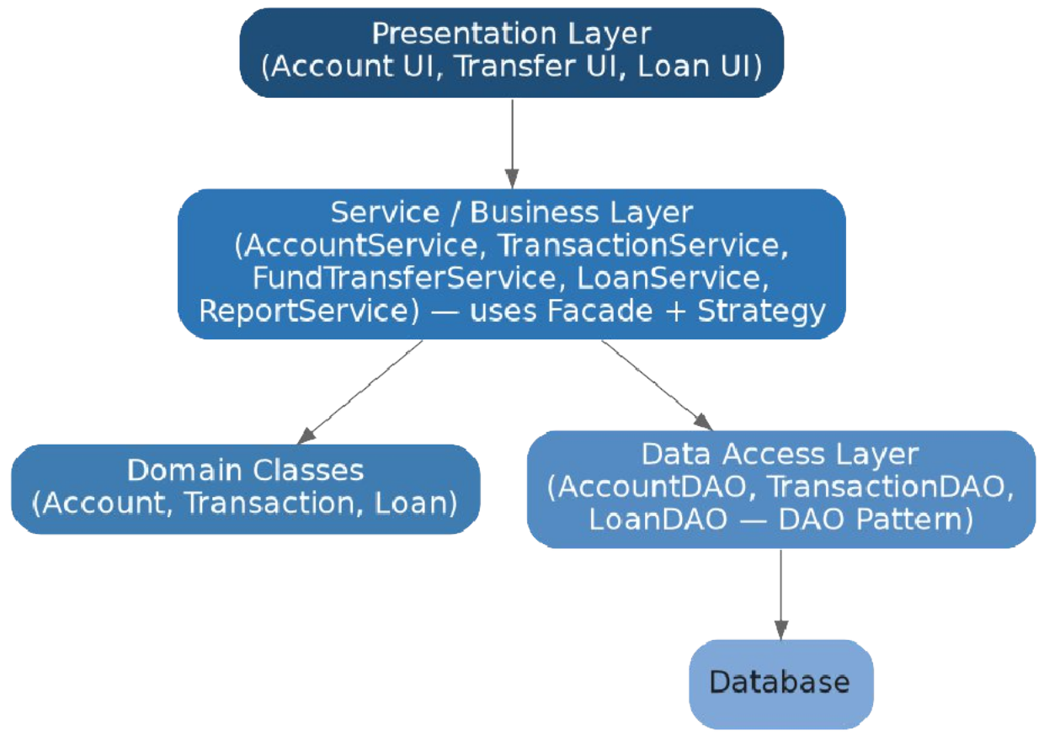
Figure 3: Redesigned layered banking architecture separating services, domain classes, and DAOs

Documentation: Improvement in Separation of Concerns, Testability, and Maintainability
Separation of Concerns: Business rules now live exclusively in the Service and Domain classes, while all SQL/OODBMS operations live exclusively in the DAO classes — no class mixes 'what to do' with 'how to store it'.
Testability: Because Service classes depend on DAO interfaces rather than concrete database code, mock DAOs can be injected during unit testing, allowing fund-transfer or loan-interest logic to be verified without a live database connection.
Maintainability: A change to the database schema or the switch to a different OODBMS only requires modifying the relevant DAO implementation; the Service and Domain layers, which contain the actual business rules, remain completely unaffected.

Q4. Legacy Hotel Reservation System

5 Marks
Scenario: A hotel reservation application directly performs OODBMS operations from reservation screens. The same database queries for rooms, guests, bookings, and payments are repeated across multiple modules.

Understanding of the System
In the legacy design, the reservation screens (Presentation Layer components) issue OODBMS queries directly — for example, the Booking screen and the Payment screen each independently write and execute their own query to fetch a Guest record, resulting in duplicated query logic scattered throughout the presentation code.

Problems Identified

Coupling: The Presentation Layer is tightly coupled to the OODBMS query syntax and schema; any schema change forces edits across every screen that queries that data.
Duplication: The same query (e.g., 'fetch guest by ID') is re-written in multiple modules (Booking screen, Payment screen), violating the Don't-Repeat-Yourself principle and increasing the risk of inconsistent query logic.
Persistence Management: There is no centralized transaction or connection management, so concurrent bookings on the same room are not safely coordinated, risking double-booking.

Identification of Components for the Redesign

Component | Pattern Role | Responsibility
IRepository<T> | Generic Repository interface | Declares add(), update(), delete(), findById() for any entity type.
RoomRepository | Concrete Repository | Centralizes all Room-related queries (availability, pricing).
GuestRepository | Concrete Repository | Centralizes all Guest-related queries (profile lookup, history).
BookingRepository | Concrete Repository | Centralizes booking creation, cancellation, and lookup queries.
PaymentRepository | Concrete Repository / DAO | Centralizes payment recording and retrieval.

Reconstruction: Introducing the Repository / DAO Pattern
Every direct OODBMS call is removed from the reservation screens and relocated into dedicated Repository classes, each implementing a shared IRepository interface. The Presentation Layer now calls a Repository method (e.g., roomRepository.findAvailable(date)) instead of writing a query, and every screen that needs guest data reuses the same GuestRepository, eliminating duplication.
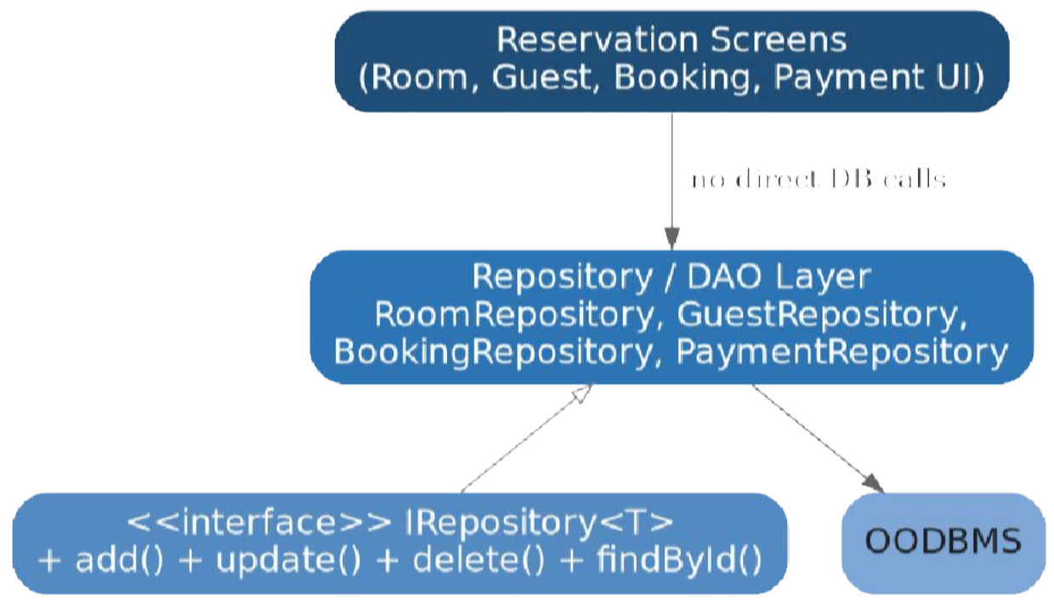
Figure 4: Repository pattern removing direct OODBMS access from reservation screens

Documentation: Improvement in Modularity, Reusability, and OODBMS Integration

Modularity: Each Repository is a self-contained module responsible for exactly one entity's persistence, so the reservation screens are reduced to pure UI logic that simply calls repository methods.
Reusability: The GuestRepository's findById() method, once written, is reused by the Booking screen, the Payment screen, and any future screen that needs guest data — the query is written once, not repeatedly.
OODBMS Integration: The Repository/DAO layer becomes the single, controlled integration point with the OODBMS, allowing transaction boundaries (e.g., locking a room record during booking) and connection pooling to be managed consistently in one place, which directly prevents the double-booking problem present in the legacy design.

Q5. Legacy Transportation Management System

5 Marks
Scenario: A transportation application contains separate modules for buses, trains, taxis, and rental vehicles. Object creation logic for each transportation type is duplicated across several parts of the application, making it difficult to introduce new transportation services.

Understanding of the System
The legacy application has separate modules for Bus, Train, Taxi, and RentalVehicle, but each module — and every other part of the application that needs a transport object — independently contains its own object-creation code (e.g., new Bus(...) scattered across booking, pricing, and scheduling modules). Introducing a new transport type therefore requires locating and editing every place that creates transport objects.

Common Abstractions and Relationships
All four transport types share common behavior — booking a seat/vehicle and calculating a fare — which can be captured in a common Transport interface. The object-creation responsibility can then be assigned to dedicated factory classes rather than being duplicated at every call site.

Identification of Components

Component | Role | Responsibility
Transport | Common interface | Declares book() and calculateFare(), implemented by every transport type.
Bus / Train / Taxi / RentalVehicle | Concrete Products | Implement Transport with type-specific booking and fare logic.
TransportFactory | Abstract Factory interface | Declares createTransport(), implemented by each concrete factory.
BusFactory / TrainFactory / TaxiFactory / RentalFactory | Concrete Factories | Encapsulate the object-creation logic for one specific transport type.
TransportBookingService | Client | Requests a transport object from the appropriate factory without using 'new' directly.

Reconstruction: Applying the Factory Method / Abstract Factory Pattern
Object creation is centralized using the Factory Method pattern: each transport type gets its own factory class responsible solely for constructing that type of object. The client (TransportBookingService) depends only on the abstract TransportFactory interface and the Transport interface, never on a concrete class directly.

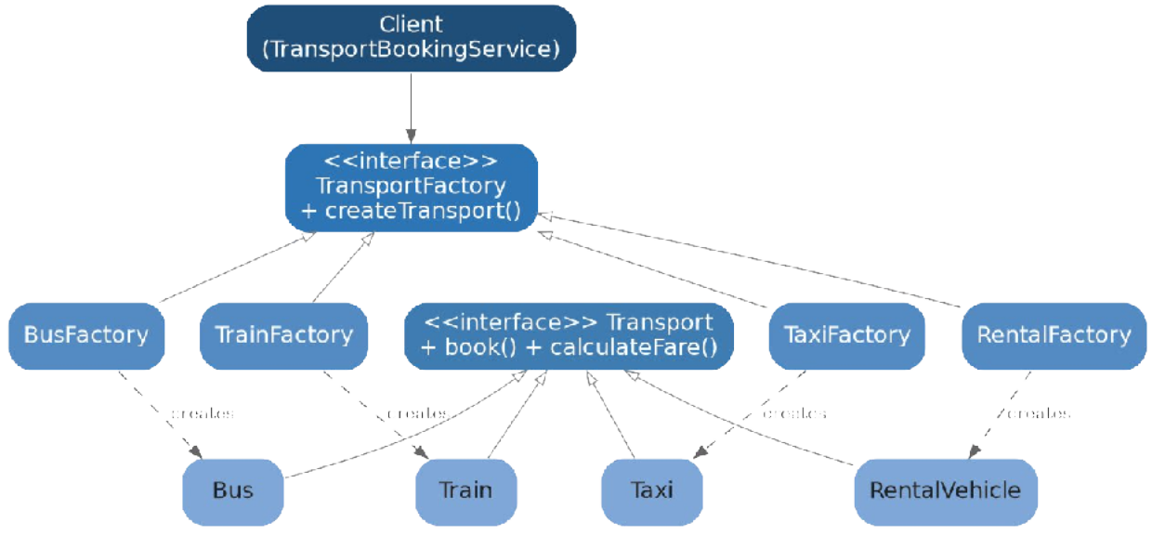
Figure 5: Factory Method / Abstract Factory pattern centralizing transport-object creation

Documentation: Improvement in Extensibility, Scalability, and Code Reuse
Extensibility: Adding a new transport service (e.g., a Metro service) requires only creating a MetroFactory and Metro class implementing the existing interfaces — no existing factory or client code is modified, satisfying the Open/Closed Principle.
Scalability: Because the client depends only on abstractions, new transport types can be introduced dynamically (e.g., loaded via configuration) as the platform grows to serve more regions or transport partners, without redesigning the booking workflow.
Code Reuse: Object-creation logic, which was previously duplicated across booking, pricing, and scheduling modules, now exists exactly once inside each factory class and is reused by every part of the application that needs a transport object, eliminating duplication and inconsistency.

Q6. Legacy Healthcare Monitoring System

5 Marks
Scenario: A healthcare monitoring application collects patient information, processes sensor readings, generates alerts, stores medical records, and produces reports. Several classes perform multiple unrelated tasks and directly depend on concrete implementations of monitoring devices and storage components.

Understanding of the System
In the legacy design, a small number of classes are each responsible for several unrelated tasks — for example, one class might collect patient information, read sensor data, generate alerts, and write to storage, all within the same class — and these classes instantiate and call concrete monitoring-device classes and concrete storage classes directly.

SOLID Violations Identified
Single Responsibility Principle (SRP) violation: A class that both processes sensor readings and generates reports has more than one reason to change — a change to alert logic and a change to report formatting both force modification of the same class.
Open/Closed Principle (OCP) violation: Supporting a new monitoring device (e.g., a new blood-pressure sensor) requires modifying existing processing classes rather than extending the system with a new class.

Dependency Inversion Principle (DIP) violation: High-level classes such as the alert generator depend directly on low-level concrete classes (e.g., ECGDevice, SQLStorageService) instead of on abstractions, making the high-level logic fragile to changes in device or storage technology.

Identification of Redesigned Components

Component | Type | Responsibility
PatientRecordManager | Class | Manages patient demographic and profile information only.
SensorReadingProcessor | Class | Processes incoming sensor readings only.
AlertGenerator | Class | Evaluates processed readings and raises alerts only; depends on abstractions.
ReportGenerator | Class | Produces reports from stored records only.
IMonitoringDevice | Interface | Abstracts any monitoring device's readSensor() operation.
IStorageService | Interface | Abstracts save()/retrieve() for medical records, independent of storage technology.

Reconstruction: Applying SOLID and Supporting Patterns
Each unrelated responsibility is extracted into its own class (restoring SRP), and the high-level AlertGenerator is redesigned to depend only on the IMonitoringDevice and IStorageService interfaces rather than on concrete device/storage classes (restoring DIP), with the concrete implementations supplied via Dependency Injection. New device or storage types can then be added by implementing the interface (restoring OCP). An Observer pattern is additionally used so that AlertGenerator can notify multiple subscribers (nurse dashboard, SMS service) when a critical reading occurs, without those subscribers being hard-coded into the generator.
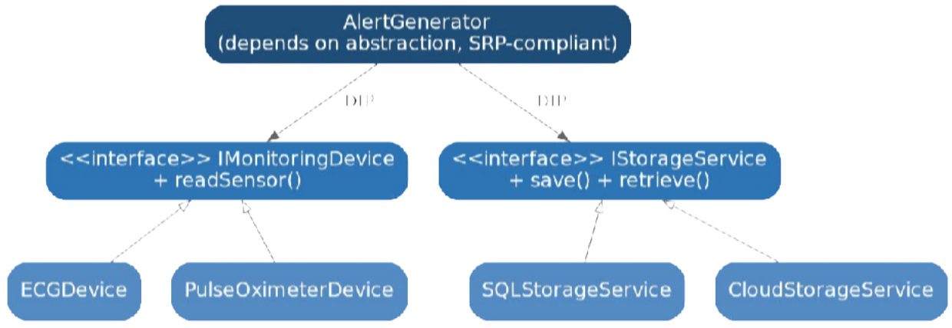
Figure 6: Redesigned classes depending on abstractions (Dependency Inversion) rather than concrete devices/storage

Documentation: Improvement in Cohesion, Loose Coupling, Flexibility, Testability, and Maintainability
Cohesion: PatientRecordManager, SensorReadingProcessor, AlertGenerator, and ReportGenerator each now perform exactly one task, so every method within a class serves the same clear purpose.
Loose Coupling: AlertGenerator no longer references ECGDevice or SQLStorageService directly; it interacts only with IMonitoringDevice and IStorageService, so the concrete device or storage technology can change without touching AlertGenerator.
Flexibility: A new monitoring device (e.g., a glucose sensor) or a new storage backend (e.g., cloud storage) can be introduced by simply implementing the relevant interface, with no change to existing alert or reporting logic.

Testability: Because AlertGenerator depends on interfaces, a mock IMonitoringDevice can supply controlled test readings and a mock IStorageService can verify save calls, allowing alert logic to be unit-tested in complete isolation from real hardware and databases.
Maintainability: Each SOLID-compliant class can be understood, modified, and reviewed independently, and the interface-based design confines the impact of any future change to a single, well-identified class.

— End of Answer Script —

